**🕵️‍♂️ 1984 Quiz 🕵️‍♂️**

**Question 1: define TOTALITARIANISM**

**Your Answer**

**Question 2:** What was the "Great Purge"?

A) A campaign of political repression in the Soviet Union during the late 1930s, resulting in the imprisonment and execution of millions.  
B) A military strategy used by the Allies during World War II to clear enemy forces from occupied territories.  
C) A social reform initiative aimed at improving agricultural production in the Soviet Union.

**Question 3:** In 1945 what was the official name of the country, Russia or Union of Soviet Socialist Republics" (USSR)?

**Question 4:** Did Stalin use photo manipulation?

Yes / No

**Question 5:** With Eastern Europe Occupied, Nazis Decimate Western Europe.

When this happened:

A: 1920-1935

B: 1940-1941

C: 1915-1918

**Question 6:** The Holocaust—Nazi Germany’s Systematic Mass Murder Campaign

A: 1941-1945

B: 1920-1930

C: 1945-1948

**Question 7:**

On December 7, 1941 Japan’s Attack on Pearl Harbor Brings United States Into World War II

true or false?

**Question 8:** Battle of Stalingrad ratified the victory of Germany

True or False?

**Question 9:** What event is commonly referred to as D-Day?

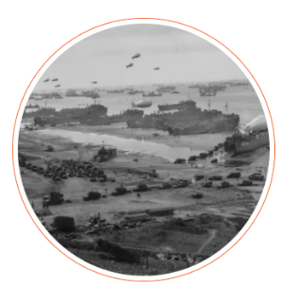

A) The liberation of Paris

B) The Allied invasion of Normandy

C) The surrender of Germany

**Question 10:** the date of the D-Day

A) June 6, 1944

B) June 4, 1944

C) June 8, 1944

**Question 11:** Which of the following was NOT one of the five landing beaches during the D-Day?

A) Omaha  
B) Utah  
C) Monte Cassino

**Question 12:** Which Allied commander was in charge of the D-Day operation?

A) General Dwight D. Eisenhower  
B) General George S. Patton  
C) General Bernard Montgomery

**Question 13:** What was the primary goal of the D-Day?

A) To capture Berlin  
B) To establish a Western front against Nazi Germany  
C) To secure resources in North Africa

**Question 14**: What was a significant outcome of the atomic bombings of Hiroshima and Nagasaki in

August 1945?

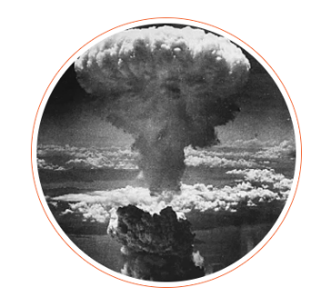A) The immediate ceasefire of Germany  
B) The surrender of Japan, leading to the end of World War II  
C) The start of the Cold War

**Question 15:** The Marshall Plan in 1948 was a U.S. initiative that provided economic aid to Western European countries to help rebuild after World War II.

True or False?

**Question 16: Creation of Israel Divides the Middle East**

What was a major consequence of the establishment of the state of Israel in 1948?

A) Immediate peace agreements with all neighboring Arab countries  
B) Increased tensions and conflicts between Israelis and Palestinians  
C) A unified Arab coalition supporting the creation of Israel

**Question 17: which one is the true statement?**

1. The primary purpose of NATO, established in 1949, was to provide collective defense and security for Western European countries against potential Soviet aggression during the Cold War.
2. NATO was established in 1949 to promote economic cooperation and trade among Western European countries without any focus on military defense.

**Question 18:** Which of the following was NOT a main totalitarian regime in Europe in 1945?

A) Nazi Germany  
B) Fascist Italy  
C) USSR (Union of Soviet Socialist Republics)  
D) Democratic France

**Question 19: True or False Exercise: George Orwell's "1984"**

1. **True or False:** George Orwell's novel "1984" was published in 1949.
2. **True or False:** "1984" was written as a direct response to the events of World War I.
3. **True or False:** The story of "1984" is set in a dystopian future characterized by totalitarian rule.
4. **True or False:** George Orwell originally intended to publish "1984" in the year 1984.
5. **True or False:** The protagonist of "1984" is named Winston Smith.

**Question 20:** George Orwell opposed the Cold War because he believed it perpetuated totalitarianism and undermined democratic values.

True or False?